

Mini Project Report ON

**“****Object, Color and Distance Detection System”**

Submitted in partial fulfillment of the requirements for the degree of Bachelor of Engineering in “**Information Technology Semester - VI**”

### By:

**Names ID No’s.**

Varun Singh VU4F1819016

Nishad Kadam VU4F1819019

Shashank Singh VU4F1819021

Under the Guidance of :- **Prof. Ashwini Phalke**



**Department of Information Technology**

**Vasantdada Patil Pratisthan’s College of Engineering and Visual Art**

Vasantdada Patil Educational Complex, Eastern Express Highway, Near Everard Nagar, Sion, Chunabhatti, Mumbai – 400022

**UNIVERSITY OF MUMBAI**

**April, 2021**



**CERTIFICATE**

This is to certify that the project entitled **“Object, Color and Distance Detection System”** is a bonafide work of **“**Varun Singh (VU4F1819016), Nishad Kadam (VU4F1819019), Shashank Singh (VU4F1819021)**”**submitted to the University of Mumbai in partial fulfillment of the requirement for the award of the degree of **“Bachelor of Engineering”** in **“Information Technology Semester - VI”**.

Prof. Ashwini Phalke Guide

Dr. SEEMA LADHE Dr. ALAM N. SHAIKH

Head of Department Principal & Campus Director



Project Report Approval for T. E.

This project report entitled “**Object, Color and Distance Detection System**” by Varun Singh, Nishad Kadam, Shashank Singh is approved for the degree of **“Bachelor of Engineering”** in **“Information Technology Semester - VI”**.

### Examiners

1.

2.

Date:

Place: Mumbai-22

**ABSTRACT**

We are making this project for the people who are deprived of vision i.e. (Unable to see the objects that are present in their surrounding). With this project we have a clear intention of helping these kind of people to recognize the objects that are present nearby them. We are trying to come up with a special kind of glasses for sightless people which is capable of recognizing not only the object but its color and distance as well.

For this Project we are going to use Deep Learning Algo such as SSD, YOLO v3, etc. and python libraries.

Submitted by:



**Names ID No’s.**

Varun Singh VU4F1819016

Nishad Kadam VU4F1819021

Shashank Singh VU4F1819019



**TABLE OF CONTENTS**

**Abstract**

1. **Introduction**
   1. Introduction 6
   2. Aim of the Project 6
2. Literature Survey
   1. Existing System 7
   2. Comparative study of literature survey 8

2.2 Proposed System 11

1. Requirement Analysis
   1. Software requirements 12
   2. Hardware requirements 12
2. Implementation
   1. Source Code 16
   2. Screen shots 23

**References**

26

# Introduction

**INTRODUCTION**

* Ever thought how is the life of a blind person, their life is full of risk. They can't even walk alone through a busy street or through a park. They shall need some assistance from others.



* They are also curious about the beauty of the world, they should have will be the excitement to explore the world, and to be aware of what is happening in front of them
* So how we solve it, we have developed a pair of smart glasses for the blind. By using it, a person can able to know what is going on in front of him.

# Aim of the Project:

* To make life of unsighted people less complicated.
* It will help them to smoothen their lifestyle.
* It will be a very cost-effective object.
* It is very easy to implement and use.



**LITERATURE SURVEY**

# Existing System

* The current system uses TensorFlow Object Detection API, it is an open-source framework built on top of TensorFlow that makes it easy to construct, train and deploy object detection models.
* There are already pre-trained models in their framework, which use different architecture and algorithms such as single shot detection, region-based convolution neural network etc. and thus provides different accuracies.
* The system then uses voice response (which conveys the name of the object) to the person using it.



# Comparative Study of Literature Survey.

|  |  |  |  |
| --- | --- | --- | --- |
| Sr. No | Paper Title | Work Description | Conclusions |
| 1) | Object Detection and Human Identification using Raspberry Pi | The aim of this paper is to investigate the development of a navigation system for blind and visually impaired people along with human identification. It is based on a microprocessor with synthetic speech output. This solution is designed to give details about human whomever they encounter. | The proposed system has been developed and its main goal is to increase the capability of blind individuals. The technique used here is a well know name in imaging |
| 2) | Smart Glasses Application System for Visually Impaired People Based on Deep Learning | In this study, we propose a smart glasses application system for visually impaired people based on deep learning. The system can use voice response to visually impaired people about the objects in front of them by uploading the photos to our backend object detection system through the camera function of smart glasses, and then download the text descriptions of the result and then use the text-to-speech function. | According to the experimental results, the average time taken from the smart glasses to the voice output is 3.788 seconds, the overall recognition rate is 96.3% |
| 3) | Object Detection and Count of Objects in Image using Tensor Flow Object Detection API | This paper mostly focuses on detecting harmful objects like threatening objects. The model is built on two classes of threatening Objects. The model is evaluated on test data for the two classes of detecting threatening objects. | We built the model using Object Detection API. We trained model nearly 4500 steps to get a loss under 0.1 which took twelve hours and when we test the model with test images it performs well by giving better results. |
| 4) | Moving Object Detection: Review of Recent Research Trends | This paper provides a brief classification of the classical approaches for moving object detection. Further, paper reviews recent research trends to detect moving object for single stationary camera along with discussion of key points and limitations of each approach | During survey it was identified that shadow, illumination variation and dynamic background are the major problems which are worked over since these problems lead to reduction in the accuracy of successive steps of analysis process i.e., classification and tracking. |
| 5) | Moving Object Detection and Tracking from Moving Camera | In this paper, we deal multi moving object detection and tracking under moving camera. Moving objects are detected by homograph-based motion detection. After moving objects are detected, we apply online-boosting trackers to track moving objects. | The key factors of our algorithm are: (1) homographic-based motion detection, (2) online-boosting tracker, and (3) the integration of tracker and detection. |



* 1. **Proposed System**
* We aim to build smart glasses for vision less people which will help them to get information about the obstacles coming in their way.
* The proposed system will detect the object which is in front of the person and will give information about it to the user with the help of audio output.
* Various attributes of the objects such as the object name, object color and object distance will be informed to the user by this system.



**REQUIREMENTS ANALYSIS**

# Software Requirements:

* + - OS: Windows 8 or Above
    - For Project:

1. Python 3.8
2. Visual Studio Code or Jupyter Notebook for Code Execution
3. Tensor-flow
4. Open CV
5. Raspberry Pi 3B
6. Camera Module
7. Speaker Module
8. Pandas and Numpy (Optional) for Data Analysis and Numerical Operations
   * + For User:
9. Eyewear



**IMPLEMENTATION**



* 1. **Code:**

Code for Object Detection of a Static Image

Image Provided: -

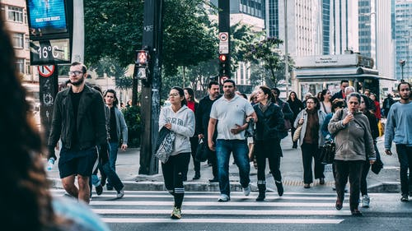

Code:-

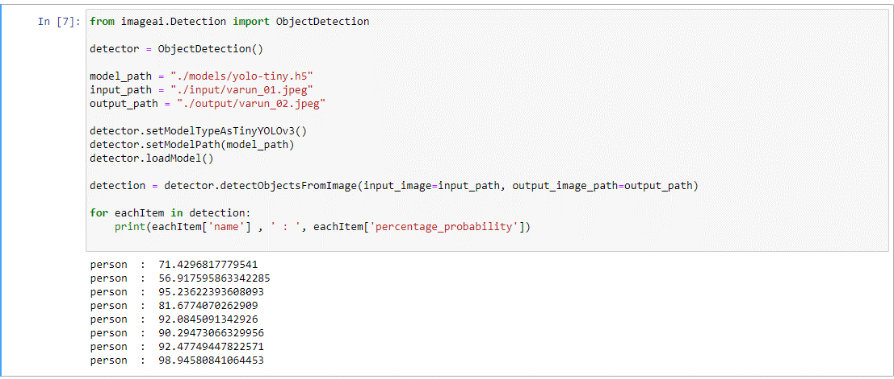

Image Received as Output:-

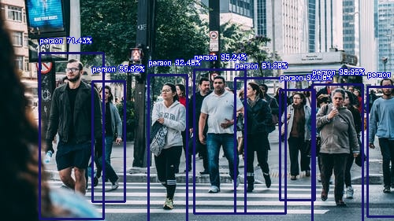



**CONCLUSION**

### In this project we were able to build a successful spectacle for the visually impaired people which will help them to Detect Object, its color, and the object's distance from the person. We were able to achieve this by using Deep learning algorithm such as SSD and YOLOv3 and python modules like TensorFlow, Keras, NumPy, Pandas and OpenCV.